VASILY KANDINSKI
Vasily Kandinsky was a Russian painter. He was one of the first artists creating “Abstract art”. He lived and worked in different European countries such as France, Germany.
He studied law and economics and he also learnt art and painting. Finally, he left his other studies to devote all his time to art.
He was very interested in colours and shapes and he considered that reality and nature were not important in art. The important thing was to simplify everything and see the beauty of your personal consideration of art.
His pictures were abstract, full of colours and strange shapes and figures.
Some of his most important master pieces are:
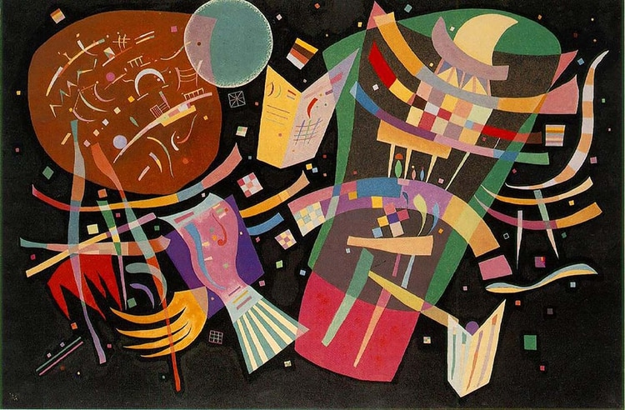
COMPOSITION X
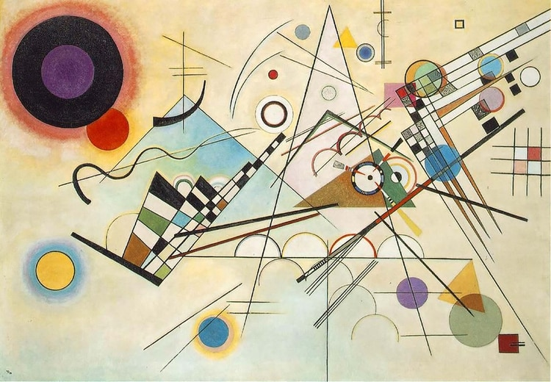
COMPOSITION VIII

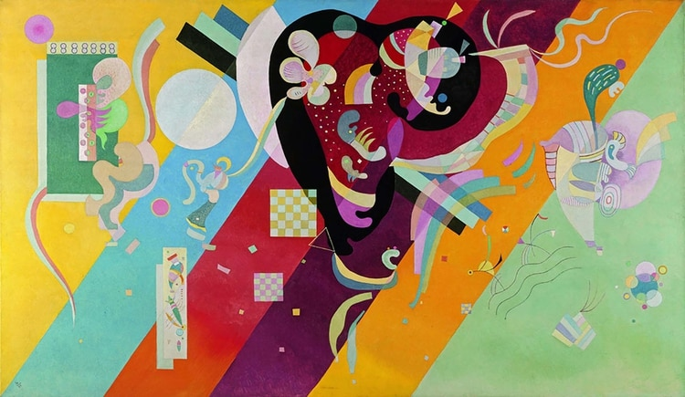
COMPOSITION IX

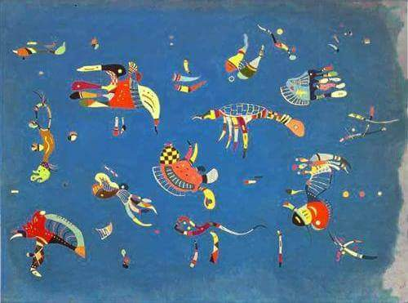
CIELO AZUL

